# Case Ref No: IC-64/2014

**THE INDUSTRIAL COURT**

**THE TRADE UNION AND LABOUR RELATIONS (NORTHERN IRELAND) ORDER 1995 (AS INSERTED BY ARTICLE 3 OF THE EMPLOYMENT RELATIONS (NORTHERN IRELAND) ORDER 1999)**

**SCHEDULE 1A – COLLECTIVE BARGAINING: RECOGNITION**

**DECISION ON WHETHER TO ACCEPT THE APPLICATION**

**The Parties:**

Unite the Union

And

Andor Technology.

# DECISION

For the reasons to be outlined in the Long Decision (to follow), the Industrial Court is satisfied that:

1. members of the Union constitute at least 10% of the workers constituting the proposed bargaining unit;
2. a majority of workers constituting the proposed bargaining unit would be likely to favour recognition of the Union as entitled to conduct collective bargaining on behalf of the bargaining unit; and
3. the application meets the remaining admissibility and validity criteria.

The Industrial Court’s decision is therefore that the application is accepted.

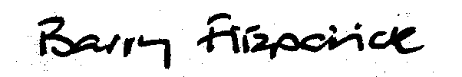

Barry Fitzpatrick

Patricia O’Callaghan

Robin Bell

Decision Date: 3rd November 2014

Date Issued to Parties: 3rd November 2014