THE INDUSTRIAL COURT

THE TRADE UNION AND LABOUR RELATIONS (NORTHERN IRELAND) ORDER 1995 (AS INSERTED BY ARTICLE 3 OF THE EMPLOYMENT RELATIONS (NORTHERN IRELAND) ORDER 1999)

SCHEDULE 1A – COLLECTIVE BARGAINING: RECOGNITION

DECISION ON WHETHER TO ACCEPT THE APPLICATION

Parties:

Unite the Union

And

Nicholl (Fuel Oils) Ltd

DECISION

For the reasons outlined in the formal decision paper (to follow), the Industrial Court (the Court) does not find the application to be valid. The Court is required by the 1995 Order to decide whether the Union’s application to the Court is valid within the terms of Schedule 1A, paragraphs 5 – 8; is made in accordance with paragraphs 11 or 12; and is admissible within the terms of paragraphs 33 to 42 of Schedule 1A to the Order.

The Court’s decision is therefore that the application does not fulfil the admissibility criteria as stipulated in the Schedule and therefore is not accepted.
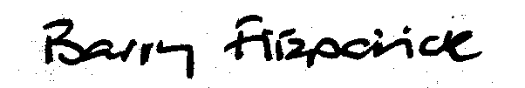

Mr Barry Fitzpatrick
Mr Robin Bell
Mrs Pauline Shepherd

Date of Decision: 22nd January 2014
Date Decision Issued to Parties: 23rd January 2014

